**Machine Design**

**Reinhard Heinrich Bertram Vinzenz Freiherr von Pelden genannt Cloudt zu Lauersfort und Impel**

**Introduction**

We started our project by determining the features that we wanted to implement in our sorting machine, like design focus, exception handling and user interaction. These design decision form the foundation for our mechanical machine design. The purpose of this document is to record the design decisions we made in the first stage of the project, from a user point of view as well as from a mechanical point of view.

**Current design**

The machine consists of a container in which the discs can be stored. When the sorting process starts, the machine calibrates the sorting wheel with 3 arms powered by a step motor using a touch sensor. Then, a disc falls onto the platform below the container. Underneath this platform, there is a color sensor pointed up. The disc is then shoved either left or right, depending on the color the sensor has detected, by the sorting wheel. The disc then falls of the platform onto a seesaw. A gyroscope is attached to the axis of this seesaw. This gyroscope will detect on which side of the seesaw this disc falls. The disc then slides off the seesaw and falls into a mountable tray.

**Design decisions**

A container used to store the discs is mounted on top of the machine. Under the container a platform is present, so that the bottom disc rests on it .This can be seen in figure 1. The vertical distance between the bottom of the container and the platform is a little bit bigger than the height of one single disc. This is to ensure that the discs resting on top of the bottom discs do not move while the bottom disc is moved by the sorting arm (the arm indicated by 2 in figure 2). This sorting arm has four legs and rotates around the z-axis, moving only 90 degrees per time ensuring that it ends in an equivalent position after each move. This arm is controlled by the regulated motor. When we received the lego set, we discovered that the set contains a single piece that functions perfectly as the sorting arm, but with only three legs. Therefore, we have decided to use three legs instead of four, for simplicity. This also means that the rotating angle will be 120 degrees instead of 90 degrees.

Opposite of the sorting arm, mounted on the other side of the disc is the colour sensor (the part indicated by L in figure 2). This sensor measures whether there is a disc in front of it (and therefore laying on the platform) and measures its color too. Under both sides of the platform (respectively left and right) a slide(part 1 of figure 1) is placed and at the end of the slide a tray. This slide ensures that when a disc is sorted (and therefore moved to either the left or the right of the platform) the disc ends in the correct tray. The left tray is destined to be filled with only black discs and the right tray with white discs. The slide also acts as a lever, pivoting around an axe that is placed somewhere under the edge of the platform. At the shortest side of the lever, under both sides of the platform above the lever, a pressure sensor(part p of figure 1) is placed. This sensor is used to detect whether a disc is traveling towards the tray. The components are constructed and mounted with lego such that no lego components block the path of the discs nor the lever or tray. In order to ensure that when a disc gets launched by the lever such that it ends up outside the machine or that it does not make contact with the lever, a vertical plate is placed as shown in the picture.

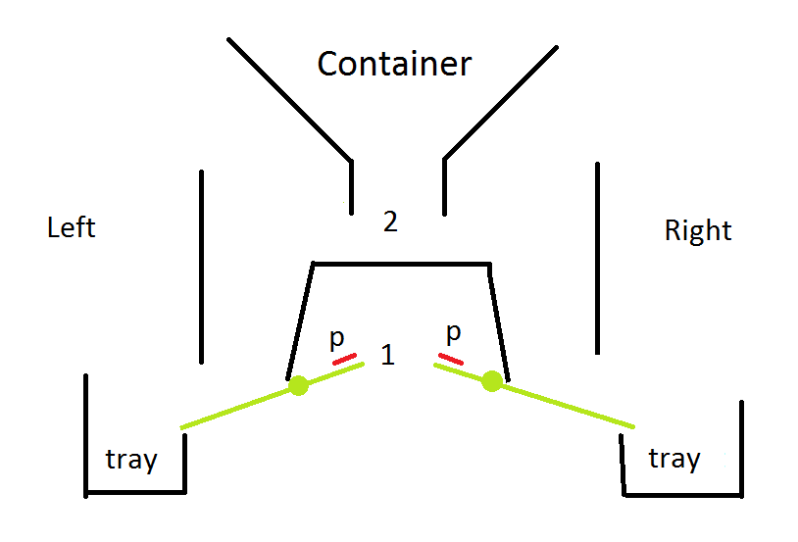

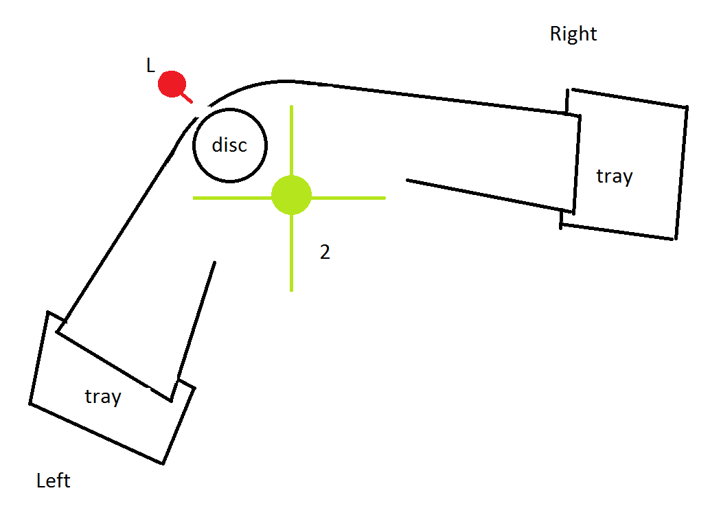

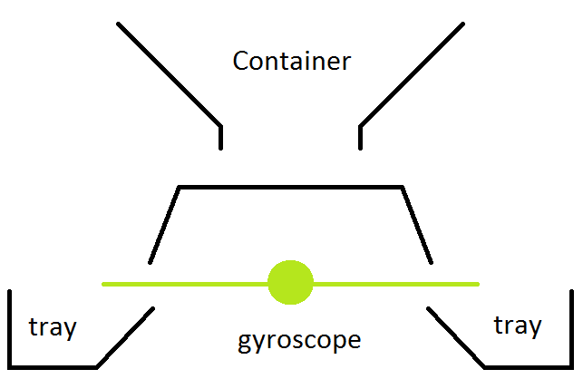

After a little bit of experimenting with the touch sensor, we noticed that they are not precise enough to detect if a disc has fallen on to the levers. The discs are too light. Our next idea was to make a kind of seesaw. When we attach the gyroscope to the center, we can detect if the seesaw turns to the left or to the right. This way, we can detect if a disc has fallen on the left or on the right of the seesaw and thus we can see if the disc has fallen into the tray.

There are a few other changes we made. First, we decided to put the colour sensor underneath the discs instead of on the side, for two reasons. Firstly, it was structurally too difficult to attach the sensor on the side of the frame. Secondly, we found that having the sensor underneath the discs provides more reliable color detection, as the discs surface area is much larger on the bottom than on the side. We also decided that making the trays mountable instead of fixed would make the machine more user friendly, as discs can be more easily removed. Creating the trays using LEGO proved very difficult, therefore we made the decision to use coffee cups instead.

The disc tube also got several modifications before we settled on a final design. Our design started with a complicated system of beams forming the tube. This system allowed us to set the width of the tube in an attempt to make the discs fit as perfectly as possible, so they would be easy to load without them turning on their side in the tube. This proved difficult however, since the system was fragile and needed adjustment often. We tried to recreate this system in a way that it would be less complex and more sturdy. This proved impossible due to the constraints of LEGO pieces. Therefore, we designed a system where the tube does not need to be the perfect size for the discs. This tube consist of some beams that are connected around a central gap of air where the discsgo. One side of the tube can be opened, such that it can be easily loaded while the tube is positioned in a horizontal direction. There is a locking stick which can be inserted on the bottom side to prevent the discs from falling through the tube while loading the discs. After the tube has been filled, it can be tilted vertically on top of the color sensor and the locking pin can be removed, to allow the discs to fall on top of the sensor.

Finally, we added an additional checking mechanism to the machine. The arms of the sorting wheel now slide over a touch sensor. This allows the machine to calibrate the sorting wheel to make sure that it is in the correct position before the sorting process starts.

**System Level Requirements (SLR)**

**Use Cases**

The machine can be described as a finite automaton. This finite automaton is shown in figure 4.

The machine has three buttons, which the user can utilize to control the machine. The START/PAUSE button is used to start and pause the machine. The ABORT button is used to stop the machine in case of emergency. The RESET button is used to reset the machine. The user is required to add black or white discs to the container before starting the machine.

The machine, when finished without fatal error, produces two trays, one filled with white and one filled with black discs. The machine will also display information about its current state and progress on the display during the sorting process.

The sorting process is described by the following automaton. The initial state is the resting state. The user is required to prepare the machine as described in the User Constraints segment further in the document. None of the buttons should have any effect, except for the START/PAUSE button. When this button is pressed, the machine should proceed to the operating state.

In this state, the machine sorts the discs. Internally, it has a state in which it checks the color of the disc, after which it moves to the correct sorting state in which it transports the disc to the correct tray. If the RESET button is pressed in this state, the machine should return to the resting state.

While in the operating state, if the START/PAUSE is pressed, the process should halt and the machine should go into a paused state. When the START/PAUSE button is pressed again, the machine should return to the operating state at the point where it was when the START/PAUSE button was first pressed. If the RESET button is pressed in this pausing state, the machine should return to the resting state.

While in the operating state, if the ABORT button is pressed or a fatal exception is encountered, the machine should immediately go into an exception state. In this state, the machine must come to a full stop. The machine should only continue when the RESET button is pressed, after which it returns to the resting state.

When the machine finds that there are no more discs left in the storage, it should go into a finished state. Then, if the RESET button is pressed, the machine should return to the resting state.

Machine Design.png

**User Constraints**

Machine preparation

Before starting the operation of the machine with the START/PAUSE button in the resting state, the user is expected to fill the disc storage device with black and white colored discs that need to be sorted. Only discs are allowed in the disc storage and no other objects should be placed in it. The user must also ensure that no discs are present in other parts of the machine and that the disc trays are mounted to their mounting points prior to starting execution. The disc trays should be empty. At most 12 discs may place into the container. The user then has to proceed by starting the program. The tube can be filled with discs after the machine has finished calibrating the moving arm.

To Add: When booting up the machine, all the sensors should be connected to the brick. Especially the gyroscope sensor should be connected when booting the brick up. More importantly, the gyroscope, and therefore the whole machine should hang completely still and should not move.

After the machine has finished execution, the user will have access to two trays, one containing exclusively white discs, the other only contains black discs. When the machine indicates that it has finished its sorting procedure, the user should remove the trays from their mounts so he can dispose the discs somewhere else.

Exceptions

Possible errors are as follows:

|  |  |
| --- | --- |
| Error Type | Fatal (to abort state requires user input to continue) |
| Disc does not reach the basket | Yes |
| Disc arrives in the wrong basket | Yes |
| Time to basket is higher than average | No |
| Wrong input (i.e. different color disc) | No |
| Motor jams | Yes |
| Gyroscope does not stabilize | Yes |
| Connection to peripheral lost | Yes |
| Battery low | Yes |
| Abort by user | Yes |
| Software exception | Yes |

When a disc does not reach the basket, the machine should stop, as there is may be an obstruction in the path the disc takes from the sorting arm to the lever.

When a disc arrives in the wrong basket, the machine should stop, as something happened that caused the disc to move to the wrong basket, even though the sorting arm tried to move it to the correct basket. This means there must be a mechanical failure somewhere.

The ‘Wrong Input’ error occurs when a disc is being detected with another color than white or black. This could, for example, be a disc with the color red. This is not a fatal error because we can specify an action that will be taken when this exception occurs. We may for example want the machine to simply put the unknown disc in one of the trays anyway, say default the destination to white, or we dispose all unknown discs into a separate tray.

The connection to peripherals lost exception is marked as a fatal exception, because a defect in the controlling parts of the machine prevent it from functioning properly for obvious reasons. The user has to fix this by hand before the machine can be used again.

The machine will stop operation when the battery has less than 5% of charge left. This is done to prevent the machine running out of power in between operations and ending in an invalid state.

When an error occurs in the machine that is indicated with ‘fatal’, the user must remove all discs from all parts of the machine. The user should then press the RESET button in order to put the machine in its resting state. The user may then proceed to prepare the machine for execution again, as described above, if desired.

**Safety properties**

The machine should have the following safety properties. These are our guarantees about the working and stopping conditions of the machine, in case something unexpected happens.

* The ABORT button must stop all moving parts within 10 ms. This to make sure that the user is able to quickly stop the machine in case something can not be handled by the machine.
* When the machine starts with discs loaded into the container, then the discs will be sorted when it arrives in the finished state. The sorting process takes at most 5 minutes in the default safe mode. However software specification may specify more modes.
* A fatal exception must stop all moving parts within 10 ms. This ensures that the machine does not damage or even destroy itself when it is blocked in any way.

# Machine interface

## Lejos API

The Lejos API provides access to buttons on the brick, sensors and actuators. Buttons can be queried directly, but references to sensors and actuators must be instantiated with a 'Port' parameter indicating how they are connected to the brick. The following ports are used in our design:

|  |  |
| --- | --- |
| **Peripheral** | **Port** |
| Color sensor | Port 1 |
| Gyroscope | Port 2 |
| Touch sensor | Port 3 |
| Motor | Port A |

Motors expose methods that allow the developer to rotate the motor an arbitrary amount of degrees. Note that we do not need to implement pulse width modulation, since we can already precisely control the motor through the API. Information about the motor’s current state can be acquired by calling a method to fetch a sample from a sensor in the form of an array of floats. It is up to the developer to parse these in a meaningful way.

**Motor rotating arm**

This motor is connected to port A and rotates the arm which moves the discs. The arm has three legs with an angle of 120 degrees. The motor has three states: a resting state and two working states, one for every possible direction. The neutral position of the three legged arm is the position where the two arms closest to the place where the disc will land have an approximately identical distance to the disc. When the motor is in the resting state the three legged wheel has this neutral position.

When the motor is in a working state the arms rotate left or right until the next neutral position of the wheel (120 degrees further), where it will transition to the resting state of the motor. During the working state the motor should not be jammed or obstructed in any way, or an exception will be triggered.

**Touch sensor calibrator**

The touch sensor, connected to port 3, is attached in such a way behind the sorting platform that the arms of the sorting wheel are able to fully press the sensor when it rotates. This way, it is possible to detect the position of the sorting wheel when it is rotating.

**Gyroscope with seesaw**

To the seesaw a gyroscope is attached, which is wired to port 2. The seesaw has three states, a neutral state, a left-side down state and a right-side down state. The neutral state is the state in which the gyroscope when read returns a value indicating that it is in balance. The seesaw enters a left-side down state when a disc falls on the left side. The gyroscope will read a value indicating that it was unbalanced and that the left side went down. This is analog for the right side down state.

**Colour** **sensor**

The colour sensor, connected to port 1, gives a value indicating the colour of the surface above the colour sensor. The colour sensor returns an integer indicating the colour of the disc (e.g. 0 for red, 1 for green etc.) currently on the platform, or -1 if only ambient light was reaches the detector, indicating that there is no disc on the platform. The sensor is able to distinguish 15 different colours:

|  |  |
| --- | --- |
| **Constant Field** | **Value** |
| [**BLACK**](http://www.lejos.org/ev3/docs/lejos/robotics/Color.html#BLACK) | 7 |
| [**BLUE**](http://www.lejos.org/ev3/docs/lejos/robotics/Color.html#BLUE) | 2 |
| [**BROWN**](http://www.lejos.org/ev3/docs/lejos/robotics/Color.html#BROWN) | 13 |
| [**CYAN**](http://www.lejos.org/ev3/docs/lejos/robotics/Color.html#CYAN) | 12 |
| [**DARK_GRAY**](http://www.lejos.org/ev3/docs/lejos/robotics/Color.html#DARK_GRAY) | 11 |
| [**GRAY**](http://www.lejos.org/ev3/docs/lejos/robotics/Color.html#GRAY) | 9 |
| [**GREEN**](http://www.lejos.org/ev3/docs/lejos/robotics/Color.html#GREEN) | 1 |
| [**LIGHT_GRAY**](http://www.lejos.org/ev3/docs/lejos/robotics/Color.html#LIGHT_GRAY) | 10 |
| [**MAGENTA**](http://www.lejos.org/ev3/docs/lejos/robotics/Color.html#MAGENTA) | 4 |
| [**NONE**](http://www.lejos.org/ev3/docs/lejos/robotics/Color.html#NONE) | -1 |
| [**ORANGE**](http://www.lejos.org/ev3/docs/lejos/robotics/Color.html#ORANGE) | 5 |
| [**PINK**](http://www.lejos.org/ev3/docs/lejos/robotics/Color.html#PINK) | 8 |
| [**RED**](http://www.lejos.org/ev3/docs/lejos/robotics/Color.html#RED) | 0 |
| **WHITE** | 6 |
| **YELLOW** | 3 |

**The brick**

The brick controls the sensors and actuators. The state of the buttons is either up or down, which may be queried using the Lejos API. The buttons used are shown in figure 5.

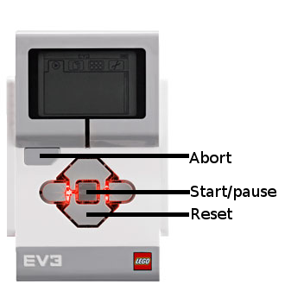

**Wrapping up**

The design decisions recorded in this document will be built upon in the next phase of the project, where we are going to specify the software specifications. The software specifications are heavily dependant on the machine interface described in this document, since the machine interface describe our assumptions about the machine API and the mechanical implementation. The software specifications will describe how we are going to use this interface and how the machine will behave.